Star of the North

Annual Report 2021

The Star of the North Retreat House
3A St. Vital Ave
St. Albert, AB T8N 1K1
Phone: 780-459-5511
Email: admin@starofthenorth.ca
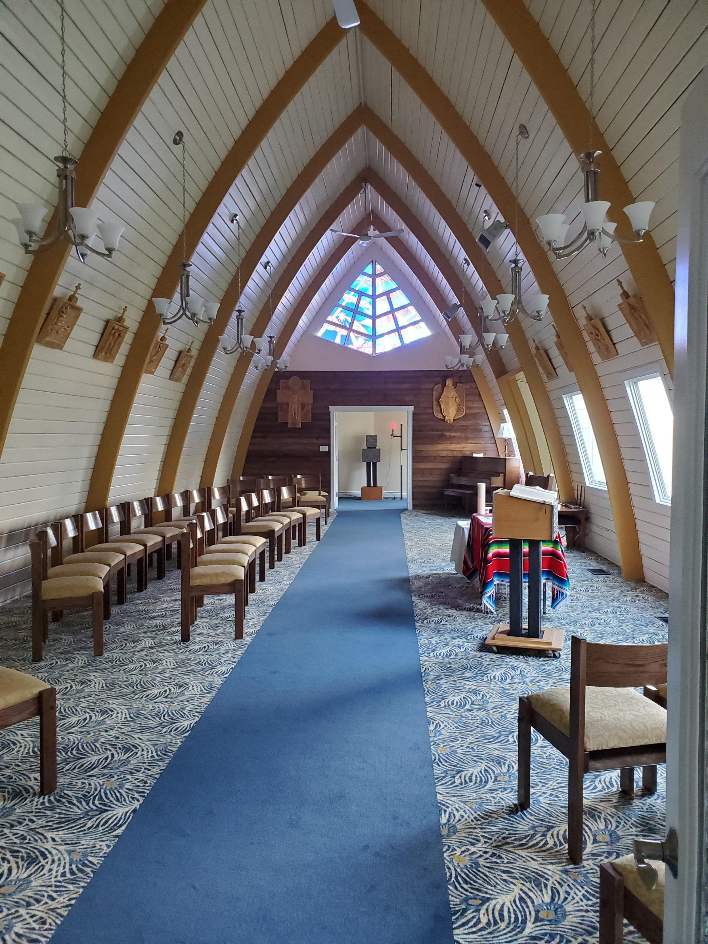
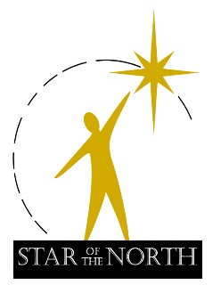

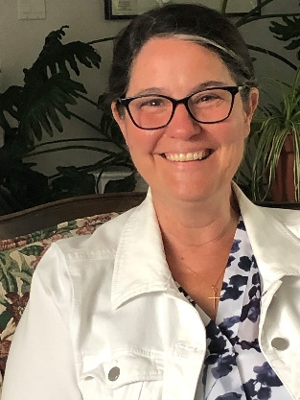
Director’s Message

Lucie Leduc

Overview of January to December 2021

I have a book on my shelf called “Finding Our Way Again” by Brian McLaren. Its subtitle is “The Return of the Ancient Practices” referring to the return of ancient spiritual practices that “…could be called life practices or humane practices, because they help us practice being alive, and humanely so.”

Just leafing through the pages and seeing the title speaks to me of what it was, and is, to live through 2021 – the second year of the pandemic with all the curves, ups and downs this entailed, and the invitation to new practices for life to bloom in the wilderness of Covid times. The Star of the North Retreat House had similar challenges as many other non-profits, retreat centers and businesses around the world. Like others, we were faced with a crisis that invited an opportunity to find our way again. We had to rely on creativity, intuition, new organizational practices to live into this very new reality of hybrid Zoom and on-site gatherings, with fewer people in-person and more online use than we imagined sustainable.

It was a harder year in many ways, not the least financially, than the first year of the pandemic. On several occasions, groups scheduled to come for meetings or retreats ended up cancelling. It was also a year of faith in providence, hope and promise as we planned and promoted our signature program “Aurora Living” and found our way through to new life. We carefully grew a staff team to work together from a view of hope, faith and charity / hospitality of ministry so needed for our times.

The pages that follow will reveal snapshot views and charts describing the reality that was 2021 for The Star of the North Retreat House. We trust we will continue finding our way with hard work, grace from God, and the outstanding support of so many volunteers, patrons, and donors.

“Let us ask ourselves: am I capable of an outburst of generosity, or do I restrain the impulses of my heart and close myself off in routine, in fear? Jump in, dive in. This is today’s word from Jesus.” Pope Francis, Missio, Tuesday May 3, 2022

Vision
Awaken to Spirit – Transform the World
Mission
- Offers a sacred space of hospitality and healing;
- Provides support and challenge for prophetic ministry;
- Awakens people to their personal dignity, beauty, and gifts;
- Engages the community in active evangelization, and the care of all of creation;
- Empowers people to grow in the service of others and the love of the Creator.

Values
- An environment for spiritual growth and prayer
- The wholeness and wellbeing of the person
- Silence, reflection, and contemplation
- Active listening and contemplative engagement
- Authentic witness to the gospel of Jesus Christ
- The diversity of human experiences and relationships
- The faith traditions and cultures of others
- The gift, dignity, and integrity of creation

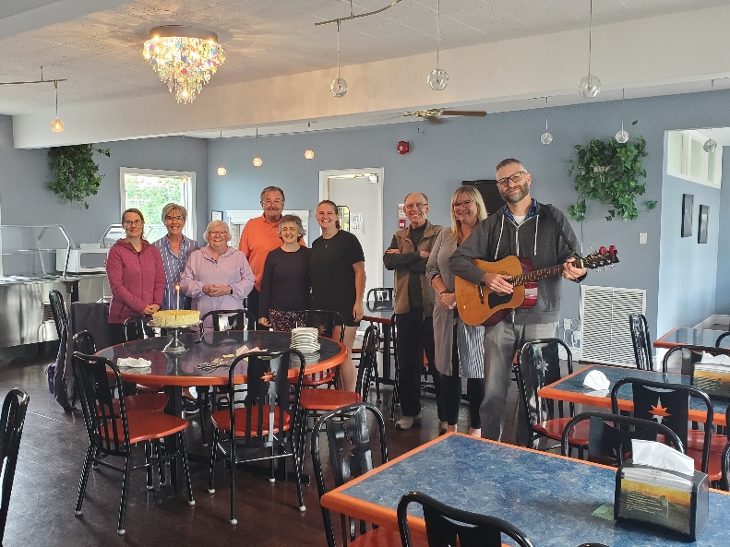
Staff, Volunteers and Star Board of Directors 2021
Staff
The year 2021 saw some staff changes and transitions from which a new configuration for program staff emerged.
Clint Porritt, our full-time Program Development and Communications Director since August 2020, has done remarkable work at hosting hybrid programs and creating attractive tracks and newsletters, as well as presenting inspiring sessions on ecology and community engagement.
Sr. Mariangel Marco Teja, an Ursuline of Jesus from Spain, joined the programming team as part-time program coordinator in January 2021.
Donna and Greg Ebert maintain security and housekeeping, making sure the facility is safe, clean and welcoming.
Terry Rego and Donna Radke split the year as Guest Facility Coordinator. Terry from January to August and Donna Radke since October.
Crystalle Krukowski, a Red Seal Chef, came on board in August.
Beth Tolentino and Meg Oeschlin returned to the Star as part-time kitchen assistants. Tony Buccini, hired in December2021, assisted with kitchen demands.
Gary Simpson provided contract hours to complete the chapel project.
Volunteers
In April 2021, volunteers interested in transforming the front and rear yard of the Star came with shovels and forks in hand and plenty of mulch to landscape The Star’s perimeter. Ongoing help brought new life and beauty to the front and back of The Star. Thank you! Collette Oddleifson, Louise Seymore, Linda Winski, Bernie McCracken, Br. Don Claerhout, Deanne Riopel, Irene Wilson, John, and Raymonde Schile.
In-house volunteers continue to provide hospitality and a welcoming environment. Thank you! Sharon Tusor, Jeannie Boutin, John, and Raymonde Schile.
Board of Directors
In 2021, we bid “goodbye” and say “thank you” to:
Fr. Mike McCaffrey, a Star of the North Board member for nineteen years since 2002, who passed away in January.
Terri Polet, Mary-Lou Veeken and Fr Alfred Groleau OMI who, after completing their term, went on to other ventures.
We say “hello” to:
Fr. Mark Blom OMI who became the Oblate representative on the Board in June.
Catherine Twinn who joined in December.
There are currently nine people on the Board.

Sponsored Facility Programs
The Star of the North is a sacred place set apart for people to experience radical hospitality, peace, and rejuvenation. The Star endeavors to walk with others on the spiritual journey, to “Awaken to Spirit – Transform the World” and manifest the reign of God in our world.

The Program Team develops programs in the spirit of the Oblate charism and informed by the Catholic Church tradition. Retreats, workshops, and formation events align with our vision, mission, and values in service of the spiritual growth and well-being of people seeking

- Renewed relationship with God and faith community:
Conversion in the Ordinary Lenten Retreat, Mar 2021 (17 pp); “Blessing Our Way to Wholeness” Ron Rolheiser retreat, Dec 2021 (54 pp); “The Four Quartets of Advent Retreat, Dec. 2021 (12 pp); Chez Marthe, Marie et Lazare: French Retreat, Sr. Catherine Grasswill, UJ, Mar 2021 (27pp)

- Deeper prayer life through meditation and contemplative practice
weekly Centering Prayer support group; Aurora Living Module 1: Creation, Sept to Dec 2021 (21 pp); Bridges to Contemplative Living, Anita Allsopp, Jan 2021 (10 pp)

- Lifestyle of Gospel integrity through Catholic Social teaching and practice, Truth and Reconciliation
Aurora Living Monthly Rituals, Jan to August 2021, (87 pp); Aurora Living Module One: Creation, Sept to Dec 2021 (21 pp); Together We Heal, Sept (23 pp), Oct (32 pp), Nov (44 pp),

- Integral Ecology as expressed in Pope Francis’ letter to the world “Laudato Si” –
Aurora Living Rituals and Module 1: Creation
Seasons of Our Lives with Debbie Doornbos, May 2021, (12 pp); “Encounter with St. Kateri Tekakwitha”, Apr 2021 (24 pp)

- Accompaniment in bereavement, healing, forgiveness, and reconciliation on the spiritual journey, and Twelve Step events
“Healing the Healers” Jan (34 pp online), & Apr 2021 (36 pp online); Bereavement series with Wanda Lehman, Sept 2021, (6 pp); Walk a New Path, with Archbishop Emeritus Sylvain Lavoid, Oct 2021, (20 pp)

- Personal spiritual growth
e.g., Listening to Your Life, Refugia Retreat, Feb 2021 (8 pp); Have Faith in Your Doubts, Clint Porritt, Nov 2021, (10 pp)

Note: “pp.” = people who attended both online and onsite – there is overlap of people, as seen above, in a variety of areas on the chart.

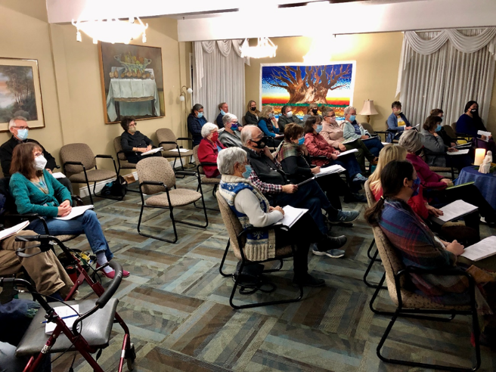

Aurora Living: Spiritual Formation Through Word and Creation
The Star Program Team, Clint Porritt, Sr. Mariangel Marco Teja, UJ, Archbishop Emeritus, Sylvain Lavoie, OMI and Lucie Leduc, developed nine rituals from Jan to Sep 2021 to introduce the nine module themes of the new signature Spiritual Formation program “Aurora Living”: Creation, Wilderness/Exile, Leadership, Psalms, Wisdom, Prophets, Gospels, Letters, Revelation.

The first Module on Creation, October-December, opened to twenty-one participants with a weekend retreat followed by monthly day-sessions and wisdom circle sharing. An array of exceptional facilitators guided the learning process and online resources deepened the knowledge.

Aurora Living provides formation and experiential learning in the Word of God, creation, contemplation, justice, and communion. Testimonials are encouraging and powerful.

“I love any learnings that expand and challenge my understanding of Scripture. I did come home and look up the passages we dealt with on various occasions. I really appreciated the presentation of Reimagining Promised Land by Steve Heinrich and what treaties are all about. That was a powerful day with Scripture”

“I am so grateful to have been able to participate in this new formation program. It is a tribute to your vision and courage to bring to birth new life right here where we are.”

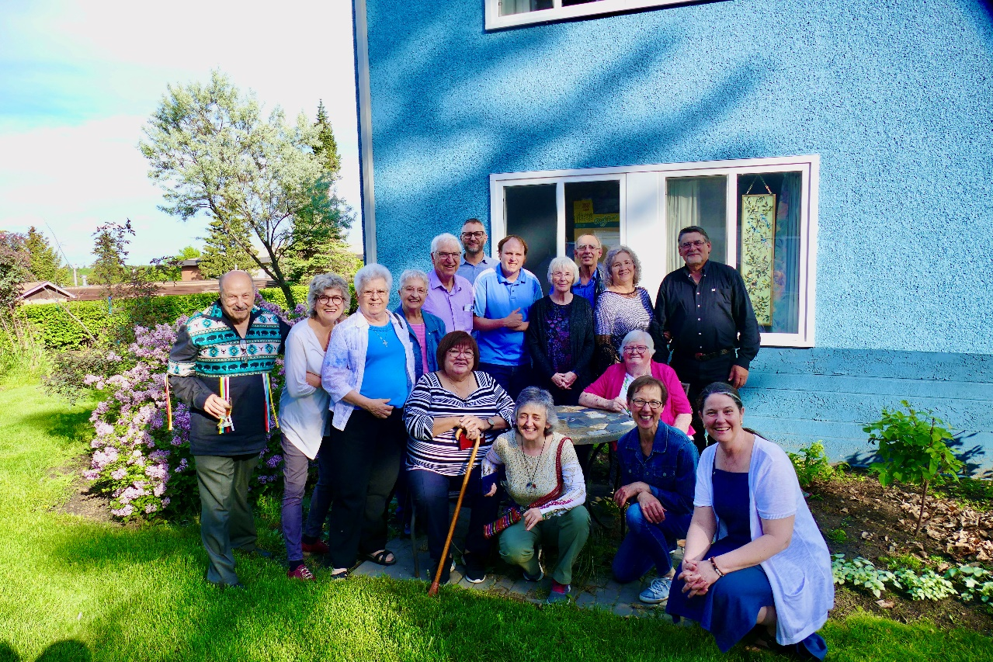

Hosted Facility Programs

Hosted programs are events planned and booked by independent religious and other groups in agreement with The Star of the North Terms and Policies.

Since the beginning of the pandemic in 2020 and through the various waves that ensued, group usage was down by more than 60% from pre-Covid years. The mainstay for bookings were AMA Impact, Twelve Step groups, yoga groups, Lesley Baartman Reflexology.

One-time events also occurred including Concordia Lutheran Women’s Retreat, Laura Remin Quilting, Mustard Seed, Catholic Social Services, Terwillegar Church retreat, Southwest Community Church, book clubs and a few others.

Private Retreatants increased noticeably in 2021 while there were fewer bookings for the Spiritual Direction room. Spiritual Directors may have preferred to maintain Zoom or opted to meet elsewhere for meetings.

Capital Campaign and Fundraising Overview 2021
The Star Board Fundraising Committee, Geneva Lander, Joyce Tutt, , Josee Marr, June Fuller, and Lucie Leduc, helped to complete the final year of the Capital Campaign (2018-2021) with two events, Camino 2021 and Christmas Letter Campaign, and several grant applications. The Capital Campaign concluded with our Chapel Renovation Project.

Two grant proposals and one major donation were gratefully received:
1) Grant with the Koziak Foundation of $5,000.00.
2) Grant with OMI Lacombe Canada - Matching Grant of $20,000,
3) Donation of $16,000 for chapel chairs received from the CWL Alberta Mackenzie Council.

Our events included the Camino, the Christmas letter campaign and the Starlight Capital giving campaign. The results were as follows:

A total of $84,010 (less GST) was used/expensed for the Chapel renovation project in 2021.
- $41,000 was grant revenue used for the Chapel project as listed above and included in the total Starlight Campaign funds seen on the chart.
- the remaining $43,324 for the Project was taken from the $88,280 received from Capital Campaign donations and Christmas Letter campaign donations,
- $121,402 of donations received were general non-allocated donations. (See year end financial report p. 4, Revenue, Donations, Actuals)

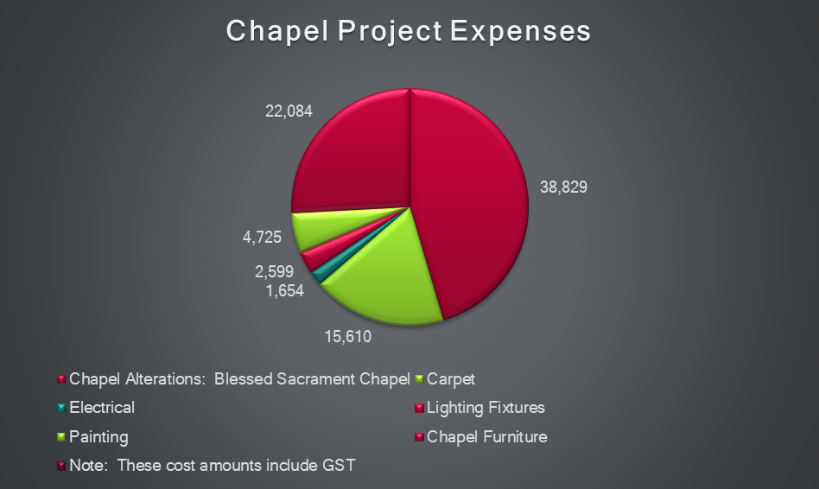

Summary Conclusion
This past year, the overwhelming support of our Star patrons and supporters enabled the Star to offer important program ministries such as Together We Heal, Men’s Inner City Wellness Retreat, and Aurora Living. Their commitment to the Star propelled the successful completion of the capital project.

What a journey! What gratitude to God for the generosity of so many people, donors and groups, the Oblates of Mary Immaculate, the staff, the volunteers, and the Board of Directors for staying the course in pandemic times. Thank You!

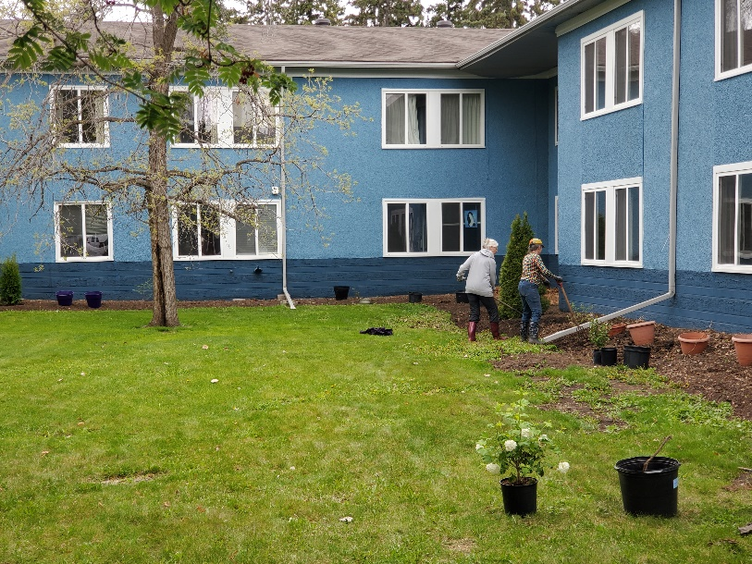

McLaren, Brian, Finding Our Way Again: The Return of the Ancient Practices, p. 14, Thomas Nelson Pub., 2008

